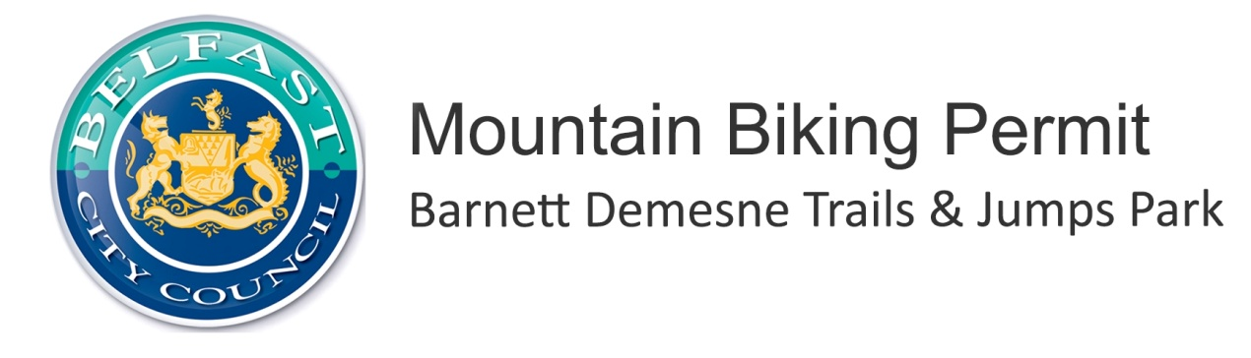
Leading of Mountain Biking Activities - Annual Mountain Biking Permit Application Form
Those organisations wishing to lead mountain biking i.e. coaching or guiding either on a commercial or non commercial basis on the Barnett Demesne Trails & Jumps Park must apply for an 'Annual Mountain Biking Permit.'
This permit entitles the holder to:
- Deliver mountain biking coaching or guiding on the purpose built mountain biking trails within Barnett Demesne Trails & Jumps Park
- Promote the aforementioned services via the designated trail page on the official website - MountainBikeNI.com
Please note:
- The number of participants on any given day should not exceed 20 otherwise this constitutes an event and should be applied for through the appropriate method.
- The permit holder must carry a copy of the permit with them on each trip to allow inspection by Belfast City Council staff. This will be carried out on a spot check basis.
- The permit allows for coaching or guiding only on the official mountain bike trail system and does not permit this activity at other locations within the park
- The permit holder may not close or divert sections of trail
- The permit holder must comply with the Mountain Bike NI code of conduct at all times
- The permit is valid for 12 months from date of issue.

Annual Mountain Biking Permit Application Form
Organisation Name
Main Contact Name
Address
Telephone Landline
Telephone Mobile
Email Address
Date from which permit to start
I have enclosed a copy of (please tick):
Y/N
Public Liability Insurance Certificate (covering the delivery of mountain biking) to the minimum value of £5 million

Risk Assessment for leading mountain biking within a trail centre environment

Qualifications of each member of staff to be covered by this permit - see requirements & template below

N.B. You may add to your list of instructors throughout the year by providing a copy of their qualification.
Applications will not be accepted without the above information and payment
Fee:
Y/N
I have enclosed the fee of £80
Cheque made payable to Belfast City Council

Qualification Declaration:
Each member of staff must have at least one of the following qualifications as a minimum:
- Adventuremark (Organisation accreditation with mountain biking as an applicable activity)
- Mountain Bike Leader Award (MBLA) - Trail Cycle Leader (TCL)
- CTC - Trail Leader Award
- Mountain Bike Instructors Award Scheme (MIAS) - Instructor Level 2

N.B. You may add to your list of instructors throughout the year by providing a copy of their qualification.

No. | Name | Qualification | Copy of certificate enclosed
E.g. | An Other | CTC - Trail Leader Award | Yes
1
2
3
4
5
6
7
8
9
10
11
12
13
14
15
Add additional sheets as necessary. Applications will not be accepted without the above information and payment
Declaration:
I understand the conditions of this permit and will ensure these are adhered to by all staff within the organisation. I understand that working outside the conditions of this permit could result in removal of the permit with no refund.
Signed
Date

Please send completed applications to: Outdoor Leisure, Belfast City Council, Parks & Leisure Department, Adelaide Exchange, 24 – 26 Adelaide Street, Belfast, BT2 8GD
Tel: 02890320202 Email: leisureo@belfastcity.gov.uk

