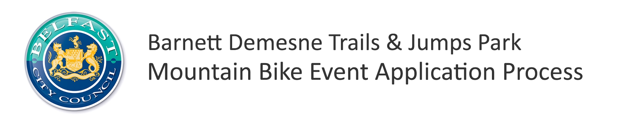
1.0 Introduction
This event application process has been established to allow the Barnett Demesne Mountain Bike Trails & Jumps Park to be managed in a responsible and effective way. The objectives of this event application process are to:
- Ensure events taking place on the trail centres are delivered to a high standard in terms of both customer experience and safety
- Allow the local area to benefit from the economic impact provided by events
- Raise the profile of the trail centre(s)
- Reduce the potential conflict caused to other trail / forest park users
- Reduce the potential displacement of regular mountain bike trail users
- Manage the physical impact of events on trails and their ongoing maintenance
- Avoid date clashes between major events across both trail centres
- Allow the Belfast City Council Parks & Leisure Department to balance facilitation of events alongside their other roles and responsibilities
- Provide an open transparent application process where responsibilities, permit and licence conditions and charges are clearly defined
1.1 Permissions
Barnett Demesne Mountain Bike Trails & Jumps Park are managed by Belfast City Council however Outdoor Reaction NI (ORNI) is responsible (via a licence agreement) for providing permission to host mountain biking events.
2.0 Guidelines
The guidelines below are designed to outline the application process, timescales and charges relevant to the size and nature of your event.
2.1 Leading of Mountain Biking Activities
Those individuals or organisations wishing to lead mountain biking i.e. coaching or guiding either on a commercial or non commercial basis on Barnett Demesne Mountain Bike Trails & Jumps Park must apply for an 'Annual Mountain Biking Permit.'

2.2 Events with less than 20 participants
Events with less than 20 participants which will have a low impact on the trail centre (not involving closure of trail(s)) and other users will not require formal permission. There may however be ongoing park operations, trail maintenance/diversions or other events taking place which could restrict access to certain areas for safety reasons. It is therefore strongly advised that you contact Outdoor Recreation NI in advance to check. info@mountaibikeni.com 02890 303 930
It should be remembered that the event organiser is responsible for the activity, the participants and the potential impact it could have on other people around. These events must comply with the 'MountainBikeNI.com Code of Conduct'.
2.2 Events with more than 20 participants
Events with more than 20 participants will require formal permission to take place, must go through the event application process and be subject to charges identified below.
Those events given permission will be provided a licence by the relevant council for each event. Please consult the Sample Licence which is provided to give guidance to event organisers as to their responsibilities. Please note this is just a sample and may be adjusted according to each event.
All applications must be made at least 8 weeks in advance.
Event Type | Definition | Charge Per Event / Per Trail Centre
Commercial | This is an event where participants are charged a fee | £500
Club | This is an event organised by a Cycling Ireland Club and not operated on a commercial basis | £300
Charity / Voluntary / Community Event - 51+ participants | This is an event organised to raise money for a registered charity, or voluntary / community organisation provided that all monies raised (after costs) are donated to that charity | £300
Charity / Voluntary / Community Event - 20- 50 participants | This is an event organised to raise money for a registered charity, or voluntary / community organisation provided that all monies raised (after costs) are donated to that charity | £100
Exceptional | Given the diversity of mountain biking, it is recognised that there may be events which do not fall into the above event types and definition and will therefore be considered on an event by event basis. | Min £100 - Max £500 - Negotiable depending on nature of the event.
All charges and fees are subject to an annual review

2.3 Application Process
8 Weeks in Advance Applications
Applicants must complete the 'Expression of Interest' form and submit to ORNI at least 8 weeks in advance of the intended event date. However please submit applications as far in advance as possible to increase the potential of receiving permission on the date you require. An 'Event Management Plan' will also be required. See application process flow chart in Appendix 1.
Event organisers must not promote the event until permission has been granted by ORNI.
2.4 Charges
Belfast City Council have made significant investment in the development, management and maintenance of the mountain bike trails therefore as with any other leisure facility they must ensure a level of income to offset these costs. Charging a relatively small fee has been identified as an means of generating income to reinvest in trail management, upkeep and development.
2.5 Services you get in return:
In return for the charge for the event, Outdoor Recreation NI will:
- Facilitate a site visit for planning purposes
- Provide introduction to other third parties which you may need to liaise with
- Discuss any issues and help seek solutions where necessary
- Raise awareness with trail users of your event and any trail diversions or closures in advance via main trail info panel and MountainBikeNI.com
- Ensure licence is issued by relevant council to run the event on agreed date
- Provide post event feedback template which must be provided to competitors
3.0 Factors to Consider
Timing of Events - Whilst events can be a key driver of visitors to a trail centre, it is also recognised that they can also detract from the experience of regular trail users. Therefore it is important to find the balance. As mountain biking is a year round activity the local councils would ask event organisers to avoid peak holiday periods such as Easter, Bank Holidays, July Fortnight etc. It is anticipated that the trail centres will already be busy at these times of years whereas a quality event could attract visitors in off peak times.
Use of Informal Trails - Belfast City Council, Rural Development Programme and Sport NI, invested just under £0.5 million to develop the Barnett Demesne Mountain Bike Trails & Jumps Park.
Given this investment, events should use the official trails and in the direction they are designed to be ridden.

4.0 Enquiries
For any enquiries on the application process please contact:
Ethan Loughrey
Outdoor Recreation NI
info@mountainbikeni.com
02890 303 930
Appendix 1 - Event Application Process Flow Chart

