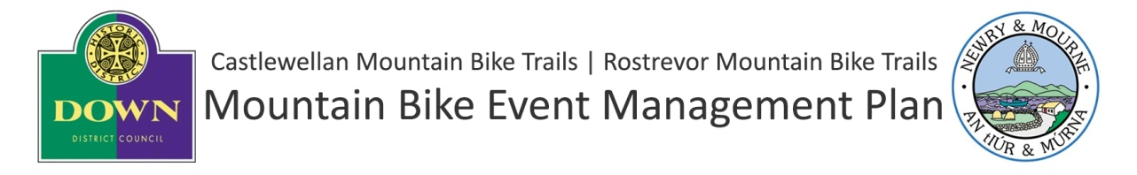
Those events that have their expression of interest approved will be requested to submit a detailed event plan at least 6 weeks before the agreed date for the event.
This must include the following:
- Details of Event Organiser - Main Contact, Address, Email, Telephone, Mobile
- Details of Dedicated Safety Officer
- Copy of event programme
- Proposed Course Map
- Proposed layout of Event HQ (if appropriate)including:
  - Info on construction of tent and marquees
  - Info on proposed outside caterers
- Risk Assessment
- Public Liability Insurance to a minimum value of £5 million to include for Event HQ, trails plus any equipment and services brought on to the site
- Child Protection Policy (if applicable)
- Event Day Management Plan to include:
  - Waste / Litter Management
  - Car Parking Management
  - Crowd Management including participants, spectators and other forest users
  - Steward / Marshalling plan
  - First Aid Provision
- Informal Trails – If the event requires the construction of informal trails – please provide the following:
  - Submit detailed plans of any required informal trails on a base map
  - Detailed specification of required informal trails (see example in Appendix)
  - Detailed construction and remediation plan including:
    - Evidence of public liability insurance to the sum of £5M covering duration of construction, event and remediation period. PLEASE NOTE: The event organiser must indemnify the trail managing council for any claim arising from informal trails during construction, event or remediation period.
    - Evidence of informal trail designers and contractors competence
    - Project Schedule - detailing construction and remediation schedule

Guidance in preparation for the above requirements can be provided on request by the Mourne Mountain Bike Ranger
Should the information required not be provided in full or to the satisfaction of the council within the stipulated period, then the permission to hold the event will be withdrawn.

APPENDIX - Example of Temporary Informal Trails Specification
Any proposed temporary informal trail must be outlined with on an Ordnance Survey Map with specification as example below :

Length
- 82m

Equivalent Grade
- Black

Trail Surface
- Natural material with imported gravel on soft spots

Trail Features
- 0.5m drop
- 1m kicker jump
- Berm

Remediation proposals
- Vegetation will be pulled back over track
- Jump will be dismantled

