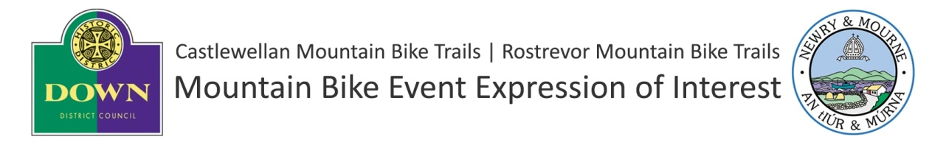
All applicants must complete Section 1
Annual Calendar Applicants i.e. 'Commercial', 'Club' and 'Charity / Voluntary / Community Event with 51+ participants' MUST complete Section 1&2.
SECTION 1
Applicants Details
Organisation
Main Contact Name
Address
Telephone Landline
Telephone Mobile
Email Address
Please outline your experience of delivering events of a similar nature and managing associated risks

Event Details
Proposed Name of Event
Event Type | Please delete as appropriate*
Commercial | Yes / No*
Club | Yes / No*
Charity / Voluntary / Community Event - 51+ participants | Yes / No*
Charity / Voluntary / Community Event - 20- 50 participants | Yes / No*
Exceptional | Yes / No*
Date of Proposed Event (Preferred Date)
Other Dates (If preferred date unavailable)
Estimated Number of Participants
Estimated Numbers Spectators

Description of Event
Will the event require the trails or sections of the trails to be closed at any time? | If yes, please provide details of sections requiring closure:
Will you require to use temporary informal trails or forest roads which are not part of the official trail system?  N.B. Only in exceptional circumstances will permission be given for events to use temporary informal trails.  The event organiser must indemnify the trail managing council for any claim arising from informal trail during construction, event and remediation period.  Please note detailed trail specification and construction and remediation plans will be required in the Event Management Plan. | YES /NO * delete as appropriate  If yes, please include detailed plans of any required informal trails on a base map with this expression of interest.

SECTION 2
Assessment Details - 'Commercial', 'Club' & 'Charity / Voluntary / Community Events with 51+ participants ' Only
The assessment panel will use the following criteria to select which events will be included in the Annual Calendar 2014. Events must score in excess of 60% to be accepted and a ranking system may be used if oversubscribed.
Please extend boxes as required.
Please outline your organisations experience in organising similar events - 40%

Please outline how your event will raise the profile of the trail centre - 25%

Please outline what steps you will take to ensure the local area benefits from the economic impact of the event - 25%

Please outline what steps you will take to ensure that the event enhances future participation in mountain biking - 10%

Declaration:
I understand this is the first phase of a two phase process.
If this expression of interest is successful the Mourne Mountain Bike Ranger will contact me to discuss the next steps including any conditions to my proposed event taking place.
The second phase will involve the submission of a detailed event management plan and evidence of public liability insurance to a minimum value of £5 million.
Signed:
Date:

Applications should be sent to:
Rostrevor
Cathy Lambert
Newry & Mourne District Council Haughey House
Greenbank Industrial Estate
Newry
Co. Down
BT34 2QU

Castlewellan
Katrina Hynds
Down District Council
Downshire Civic Centre
Downshire Estate
Ardglass Road
Downpatrick
BT30 6GQ

